# RapidPath Online Workspace

Before starting to create plans, we recommend getting to know your way around the workspace. It has been designed to be intuitive, easy to follow and to allow you the maximum available working space to create your traffic plan.

There are four main components of the RapidPath Online workspace:

* Canvas area
* Main Menu
* Toolbar
* Palettes

These workspace components are highlighted in the below.

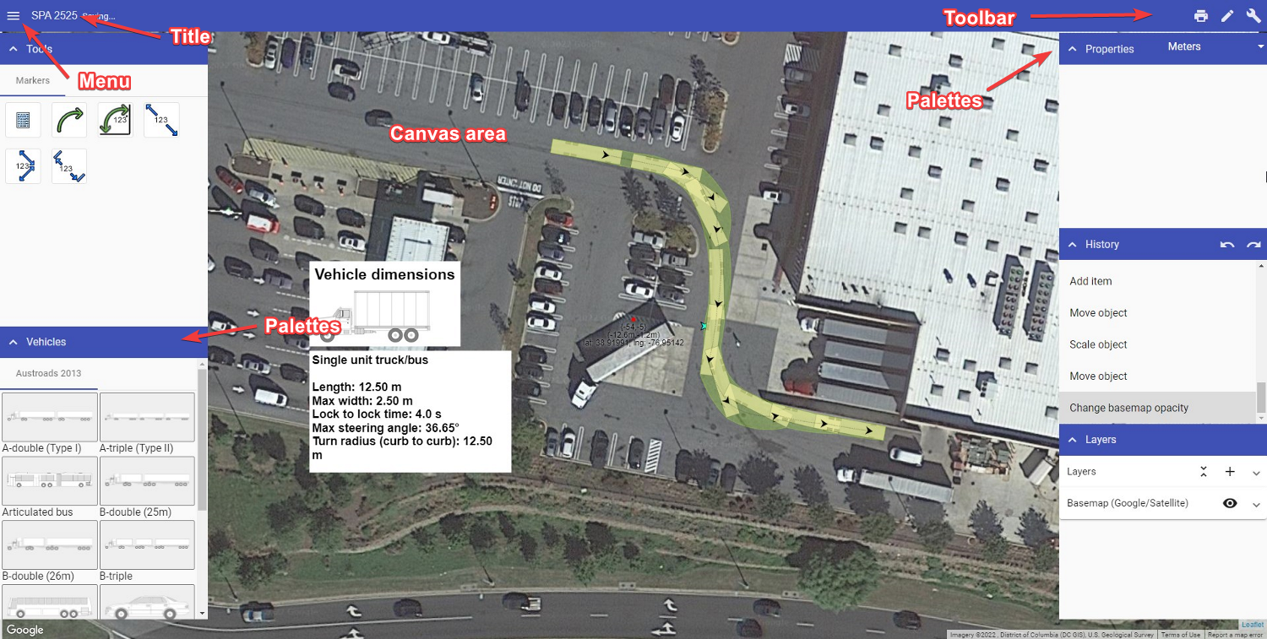

RapidPath\_Online\_Workspace

To name your plan, simply click where it mentions the plan title, highlighted above. Once renamed, the plan will autosave.

The plan author, comments and job work dates can be adjusted in Plan properties.

The following sections steps through each of component of the workspace.

## Canvas area

The Canvas area is where your swept path plan is created. When you open a new plan, a Google Maps (satellite view) of your worksite location is displayed on the canvas background.

## Main Menu

The Main menu contains a number of options to assist with plan creation. The image below shows the main tools of the RapidPlan Online menu.

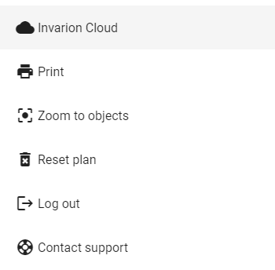

RapidPath\_menu

| **Menu Selections** | **Description** |
| --- | --- |
| Invarion Cloud | Navigates to Invarion Cloud. |
| Print | This option opens the Print dialogue box. |
| Zoom to objects | Selecting this option will return your view to where the objects are situated on your plan. This feature is especially helpful if you lose your bearings on the unrestricted canvas and wish to return to the plan’s point of origin. |
| Reset plan | This option erases all objects, signs, layers, plan location and history within a plan. |
| Contact support | Opens a webpage with Tech support contact information |

### Select tool

When drawing on the canvas area, your mouse can perform a number of functions. It can select objects, pan across the workspace and zoom in and out (using a mouse wheel). RapidPath Online offers two options for alternating between these functions - canvas button, tool selection in the main menu.

The Select tool is principally used to drag and drop objects onto the canvas area. It also has a special drag-select function, used when selecting multiple objects. Clicking (tap and hold on mobile devices) and dragging your mouse creates a selection window. The direction you drag the mouse creates a different colored window.

If you drag to the right, the window is purple. This selects objects that are completely within the purple window.

If you drag to the left, the window is green. This selects all objects touching the green window.

Examples of this are shown below.

| purple1 | Drag right (Purple) | purple2 | Object selection |
| --- | --- | --- | --- |
| green1 | **Drag left (green)** | green2 | **Object selection** |

## Toolbar

The Toolbar, located in the top right corner of the workspace, contains a number of buttons available for quick access. Each button is described below.

| Label | Button | Description |
| --- | --- | --- |
| **Print** | toolbar1 | Open the printing dialogue to print or export a plan. |
| **Tools** | toolbar5 | Show/hide the Tools palette. |
| **Operations** | toolbar6 | Show/hide the Operations palette. |

## Palettes

The palettes are located on the left (Tools) and right (Operations) of the canvas area. They can be shown/hidden by toggling the corresponding button on the Toolbar. This can be helpful for maximizing the canvas area when preparing larger-scale plans.

The Tools palette includes:

* Tools
* Vehicles

The Operations palette includes:

* Properties
* History; and
* Layers.

Each palette can be minimized by clicking the arrow icon at the top left.

The following sections describe the functions of each palette in detail.

### Tools palette

The Tools palette contains most of the elements required to annotate a swept path plan. The tools are separated into three categories, detailed in the Tables below:

#### Marker tools

| Label | Button | Description |
| --- | --- | --- |
| **Distance marker** | marker12 | Mark the distance between two points |
| **Combined distance marker** | marker13 | Mark multiple distances separated into segments |
| **Offset distance marker** | marker14 | Mark the distance between two points and offset the marker |
| **Manifest box** | marker5 | Itemizes the number of objects on a plan |
| **Arrow marker** | marker7 | Draws an arrow object |
| **Angle marker** | marker8 | Marks the angle between two points |

#### Primitive tools

| Label | Button | Description |
| --- | --- | --- |
| **Polyline** | prim1 | Draws straight lines that can be connected in a series of segments |
| **Polygon** | prim2 | Draws a polygon shape that can be filled with a custom color |
| **Spline** | prim3 | Creates a curved line along path |
| **Filled Spline** | prim4 | Creates a curved line that can be connected and filled with a custom color |
| **Bezier** | prim5 | Create a curved line with greater precision using control points and curve handles |
| **Filled Bezier** | prim6 | Create a curved line with greater precision using control points and curve handles. Fill with custom colors |
| **Text object** | prim7 | Creates an **object** out of text that can be manipulated like any other object |
| **Text box** | prim8 | Creates a box that can be filled with text |
| **Rectangle** | prim9 | Draw rectangular shapes and fill with custom colors |
| **Ellipse** | prim10 | Draw elliptical shapes and fill with custom colors |
| **Arc** | prim11 | Draw a line in the shape of an arc |
| **Arc Pie** | prim12 | Creates an arc shape that can be filled with a custom color |
| **Rounded Rectangle** | prim13 | Creates rectangle with rounded edges that can be filled with a custom color |
| **Insert Image** | prim14 | Insert an image file (jpeg, png, gif) to drop onto the canvas area |

### Vehicles palette

The Vehicles palette is the repository for each of the vehicles in RapidPath Online.

There are 2 components, **Vehicle libraries** and **Vehicle selection**.

* Your license will come with the standardized vehicles package for your region, you can choose to add more vehicle libraries to your license via your [Account portal](https://accounts.invarion.com/manage/my-company)
* You can select a vehicle by left-clicking and then left-clicking to position it on the canvas area.

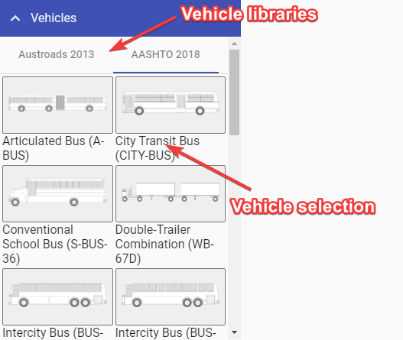

Vehicle\_palette

### Properties palette

The Properties palette displays all the information pertaining to any selected vehicles, tools, markers or objects. This is where you can change fonts, colors, etc - of a selected object.

The Properties palette allows for full customization of a vehicle path on your plan. Select the vehicle path, and you can then adjust its properties. For example, you can customize any aspect of a vehicle, as seen below.

This applies for all objects you place on your canvas area; each object has its own properties that you can edit and customize to suit your plan.

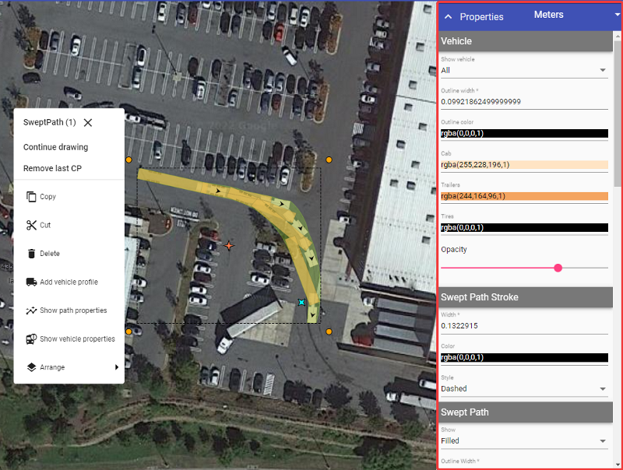

Properties\_palette

### History palette

The History palette contains the list of changes that you have made on the plan. On the top right of the palette, there are two arrows that represent undo and redo operations.

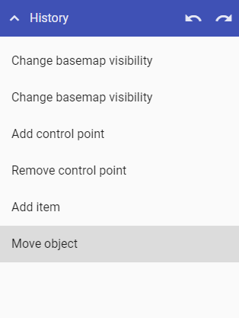

History\_palette

You can click on any of the changes made to take you back to that particular point in the creation of the plan.

### Layers palette

There will be a lot of cases where you will need to create more than one plan for a job, such as when you have different stages of work or multiple vehicle paths. That’s why RapidPath Online enables you to place multiple layers on your plan.

Layers will, more importantly, help you keep things organized in your plan. You can have a separate layer for vehicles, distances and other plan objects. Layers will improve your workflow and allow for easier changes on a more complex plan.

By default, every plan starts with only one layer, the Background.

Layers palette is divided in two sections:

* “Layers” for managing layers, and
* “Basemap” for basemap settings.

The image below highlights elements of the “Layers” section.

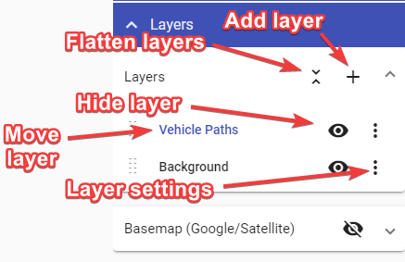

Layer\_settings

Elements in “Layers” section and their functions:

* **Add new layer** - Creates a new layer, which is then visible in the layers list.
* **Flatten layers** - Brings all of your current layers, and their objects, into a single layer.
* **Move layer** - Dragging this icon allows you to adjust the sequence of the layers in the list. This determines the order in which layers are drawn on the plan.
* **Hide layer** - This icon toggles the visibility of the layer.
* **Layer settings** - The ‘More Options’ icon allows you to rename the layer, adjust its opacity or delete that layer

Adjust basemap to your needs in “Basemap” section of Layers palette.

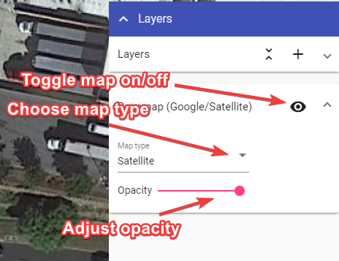

Map\_type

Elements in “Basemap” section and their functions:

* **Toggle map on/off** - Turn basemap on and off.
* **Map Type** - Change between different map types (road, satellite, hybrid, etc.).
* **Opacity** - Change basemap opacity, you can make it a little transparent so the drawn objects stand out more.

## Autosave feature

Changes made to a plan are saved automatically. The status bar located at the top of the page shows the autosave status. There are three stages which take about 4 seconds to cycle through:

* **Pending changes** - The system is updating changes made to your plan. It is recommended you don’t exit the page when changes are pending.
* **Saving** - The file is saving to Invarion Cloud. It is recommended you don’t exit the page while the plan is saving.
* **Up to date** - Your plan is now saved. It is now safe to exit the page.

**Note:** Panning across the map or changing plan location will not trigger the autosave function. You must draw or place an object on the canvas area to initial the autosave.

Status_bar

Status\_bar